HOW A MICROWAVE WORKS
Student’s name
Institutional affiliation
Course-title
Course code

How Microwave Radiations operates
Microwaves are electromagnetic radiation forms. This implies that they are magnetic energy and electrical waves that move together through space. Electromagnetic radiation spans a wide spectrum from the long radio waves to the short gamma rays. A human eye can detect only a small part of this spectrum. A radio identifies the X-ray machine uses various portions of the range and yet another piece. Radiofrequency, microwaves and visible light are non-ionizing radiation forms which do not have adequate energy for knocking electrons out of atoms (see Figure 1).
Microwaves are applied for detecting speeding cars and sending televisions and telephone communications. Industry applies microwaves to cure and dry plywood, cure resins and rubber, raising doughnuts and bread and for cooking potato chips. However, the typical microwave energy consumer is in the microwave ovens. They have three features that enhance them to be applied in cooking: they are absorbed by foods, they can be reflected by metal, they can pass through plastic, paper, glass and other similar materials (Wang & Huang 2018).
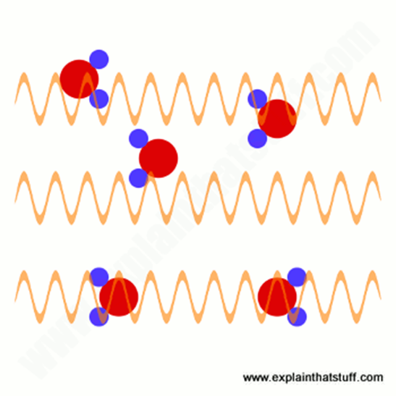
Figure 1
Cooking with Microwaves.
Microwaves are provided by an electron tube referred to as magnetron inside the Oven. The microwaves are then reflected within the Oven's metal interior where the food absorbs them. The water molecules in the food vibrate, releasing the heat responsible for food cooking. This is evident as to why the food that contains high water contents such as fresh vegetables can be cooked faster compared to other types of food. There is changing of the microwave energy for it to be heated as it gets absorbed by the food as well and does not contaminate the food or render the food radioactive (see Figure 2).
However, food is not cooked from outside by the microwave’s ovens, although there is the direct production of heat in the food. Whenever there is the cooking of thick food, the layers outside are heated and cooked majorly by microwaves while the cooking inside is mostly by heat conduction from the hot outside layers. Cooking by the microwave can be more effective and efficient than conventional cooking since the cooking is quicker and only the food is heated by the energy and not the entire compartment of the Oven. Cooking by the microwave, however, do not reduce the food's nutritional value compared to conventional cooking. In fact, food cooking by a microwave oven is likely to keep more of the minerals and vitamins since the microwave oven is able to cook food without adding water and more quickly and faster (Rajagopalan, et al 2020).
Ceramic, plastic, paper or glass containers can be used for cooking in the microwave since thy pass microwaves through. Although the microwaves may not heat these containers, they are likely to be hot from the food cooking inside heat. However, several plastic containers cannot be used in a microwave since they can melt due to the heat inside produced by the cooking food. Typically, aluminium foil and metal pans should not be applied in a microwave oven as there will be a reflection of the microwaves off these materials probably leading to damage in the microwave or having the food cooked unevenly.
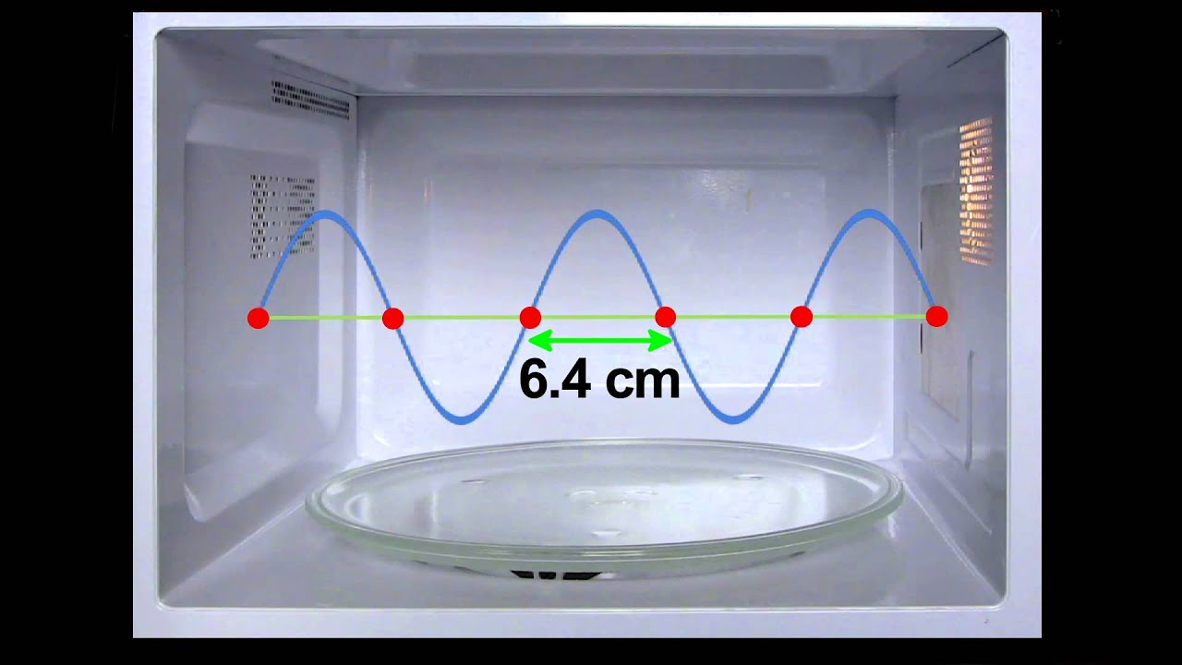
Figure 2
Does Microwaves cook from the inside out?
How the food in the microwave cooks mostly is determined by what it made from. They excite food liquids more strongly even, and that's why something having high contents of fluid in the centre will probably cook form inside out since the inside poses high contents of water. For the foods whose water contents are distributed evenly, they cook perhaps from the outside is similar to a conventional oven (Zhu,et al 2018). Because they operate by energization of the water molecules, more than conventional ovens, they dry food. Additionally, microwaves are unable to penetrate into the food more than a centimetre or two.

The safety standard of Microwave Oven
The Federal Standard limits the amount of the microwave that can leak from an oven in its entire life to five milliwatts microwave radiation in a square centimetre two inches approximately from the surface of the Oven (Cooper, 2020). The limit is far below the level anticipated to harm humans. Additionally, the energy of the microwave drastically decreases as an individual move away from the radiation source.
All ovens are also required to contain two interlock systems that are independent to stop the microwaves production when the door is opened, or the latch is released. Nonetheless, in case one of the two interlock systems fail, the monitoring system stops the operations of the Oven.
Do Injuries of Radiation result from Microwave Ovens.
Most of the microwave ovens related injuries are the outcomes of overheated food, exploding liquids or hot containers burns. Thus, most of the injuries are not associated with radiation. This implies that there are few radiation injuries instances because of improper servicing or unusual circumstances. Generally, radiation injuries of the microwave ovens are resulted by microwave radiation large amounts of exposure leaking through the openings like the microwave oven seals gaps.
Safety Tips on Microwave Operation
- Follow and adhere to the instructions of the manufacturer’s manual for recommended safety precautions and operating procedures of the microwave oven.
- If the door of the microwave oven fails to close firmly, do not operate the microwave. This also applies if the door is warped, bent or even damaged.
- Strictly use microwave-safe cookware specifically made for microwave oven use.
- If the microwave oven operates with the door open, stop using it.
- Restrain from standing directly against an oven when it is operating for long periods.
- Always refer to the manufacture’s instruction manual since some ovens are not required to operate when women.
- Restrain from heating liquids or water for longer durations in the microwave oven than recommended in the instructions of the manufacturer.
- Clean the cavity of the Oven, its outer edge regularly plus the door. The door should be cleaned with water together with a mild detergent. It is not necessary for an extraordinary cleaner of the microwave oven. Do not apply steel wool, scouring pads or other abrasives in the cleaning of the microwave oven.

References
Cooper, N. S. (2020). Microwave ovens. In Development of Packaging and Products for Use in Microwave Ovens (pp. 177-199). Woodhead Publishing.
Rajagopalan, K., Revathi, K., Revathi, B., Vishalee, S., Manojkumar, K., Batoo, K. M., ... & Kathireswari, P. (2020). Microwave assisted synthesis and characterization of Al2O3. Materials Today: Proceedings.
Wang, M. Y., & Huang, C. H. (2018). Design and Evaluation of Innovative Consumer-oriented Kitchens. KnE Social Sciences.
Zhu, S., Wang, X., Li, M., Zhu, N. H., & Li, W. (2018). A simple photonic method to generate square and triangular microwave waveforms. Optics Communications, 426, 654-657.

